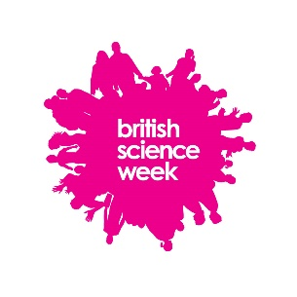
KATALYTIK: Press Release02/Time &Tide 2015
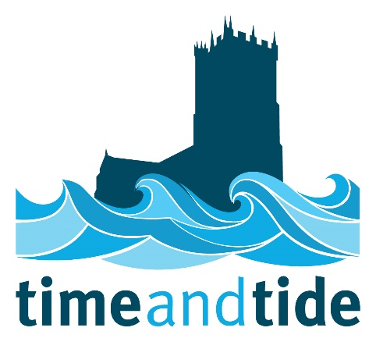

Fair in the Square
www.christchurchtides.blogspot.co.uk
Saturday 21 March 2015

A hands on science event in Saxon Square, Christchurch for all ages will enable young and old alike to explore the effect of the moon, how sea and freshwater mix and why things float or sink. Scientists from Bournemouth and Southampton University will also join in the fun from 11-4pm on 21 March.
Over the last 6 months local business Katalytik has been working with Christchurch Activities for Young People (CAYP) running Saturday science clubs and half term activities exploring the underwater world and the effect on our environment. The Science Fair, coming at the end of British Science Week aims to share our fun experiments and findings with the wider community.
“When I moved to Christchurch over 20 years ago and realised the benefits of the double high tide I wanted to share my knowledge of oceanography from my studies with the wider community. Through this project I’ve really enjoyed working with scientists and locals including historian Mike Andrews to explore how our local and very special tide have influenced the lives of so many through the ages” says Jan Peters, project originator.
The science of the tides is quite complex. Storytelling is a well-known technique for making the inaccessible accessible. We’re delighted to be working with well known storyteller and veteran of A Sting in the Tale, Martin Maudsley to help shape the story our tide.
This event is free and family friendly and no advanced booking is required. Scientists and students will be demonstrating the amazing properties of water and helping visitors explore the local environment.
A second event with a more technical description of the tides and how the tides came to be will take place with project Tide Expert, Ivan Haigh from the National Oceanography Centre.
Talking Tides, 24 March 7-9pm, Highcliffe Sailing Club, Mudeford Quay. Please help us by registering to attend by clicking through this link, emailing Helen@katalytik.co.uk or calling 0797 4011278
Click and register

Background
A community science project, Time & Tide is funded by Department for Business Innovation and Skills. Up to April 2015, local business Katalytik will be working with Christchurch Activities for Young People (CAYP) and scientists from the University of Southampton and the National Oceanography Centre Southampton to engage young people in the exploration of the tidal system as well as the science and history of the harbour environment around Christchurch.
The Department for Business, Innovation and Skills (BIS) is pleased to support this project which takes science into a community setting. A spokesperson said: “It is our hope as a result of being engaged with this project that local people will feel better informed about science issues affecting them and be inspired to be involved further in the future.”
Follow us on Facebook or visit the Time & Tide website:
http://www.christchurchtides.blogspot.co.uk
www.christchurch-macronutrients.org.uk/ for real time monitoring of the nutrient sin the Harbour and Rivers Avon and River Stour

Further information
For more information, interviews & images, please contact: Jan Peters jan.peters@katalytik.co.uk or call 0797 4011278

About Katalytik
Katalytik is a small consultancy based in Christchurch, established in 2004, developing and delivering projects across science, technology, engineering and maths (STEM). We work with educational organisations and employers to attract, retain and advance enthusiasm and passion in science and technology. We specialise in inclusion.
Katalytik is also part of the delivery team for STEM Wilts and Dorset, with Catalyst, offering strategic planning advice to schools around science, technology and maths and matching volunteers from industry with schools to support the curriculum, clubs and competitions that aim to inspire pupils about STEM subjects for more information visit www.stemwiltsdorset.org.uk

